**Lab Task #4**

**1. Display Three Attributes with a Condition:**

I selected three attributes (e.g., `student_name`, `marks`, and `grade`) and I applied logical operators to filter results.

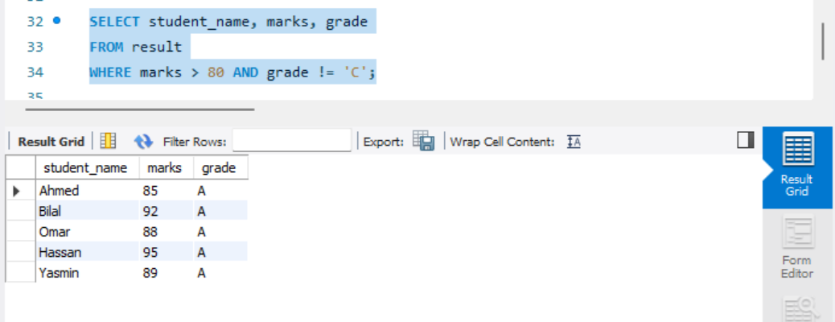

**2. Alternative Example with Different Conditions:**

I have changed the conditions to use different logical operators based on your requirements:

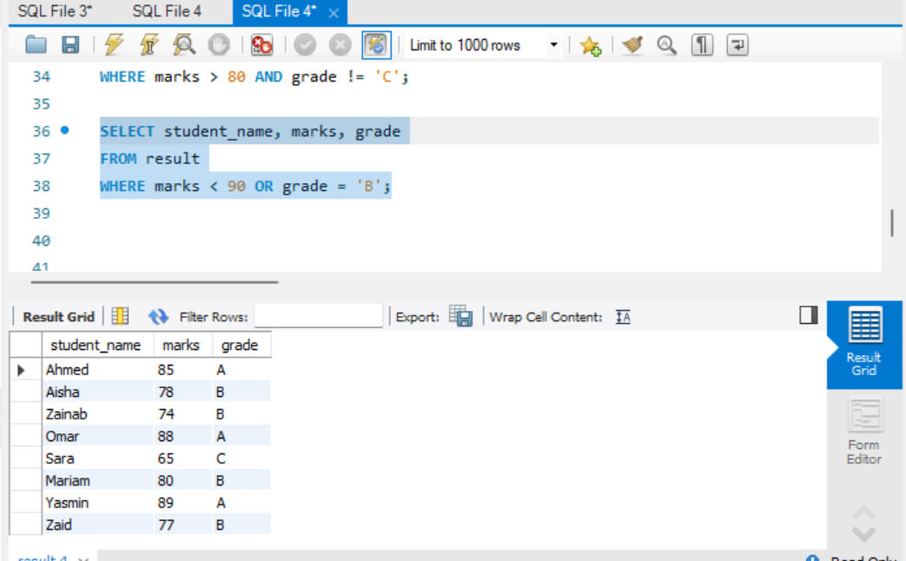

**3. Additional Example Using the Equal Operator:**

I displayed students with an exact grade:

